Oblasti riadenia kvality ovzdušia SR

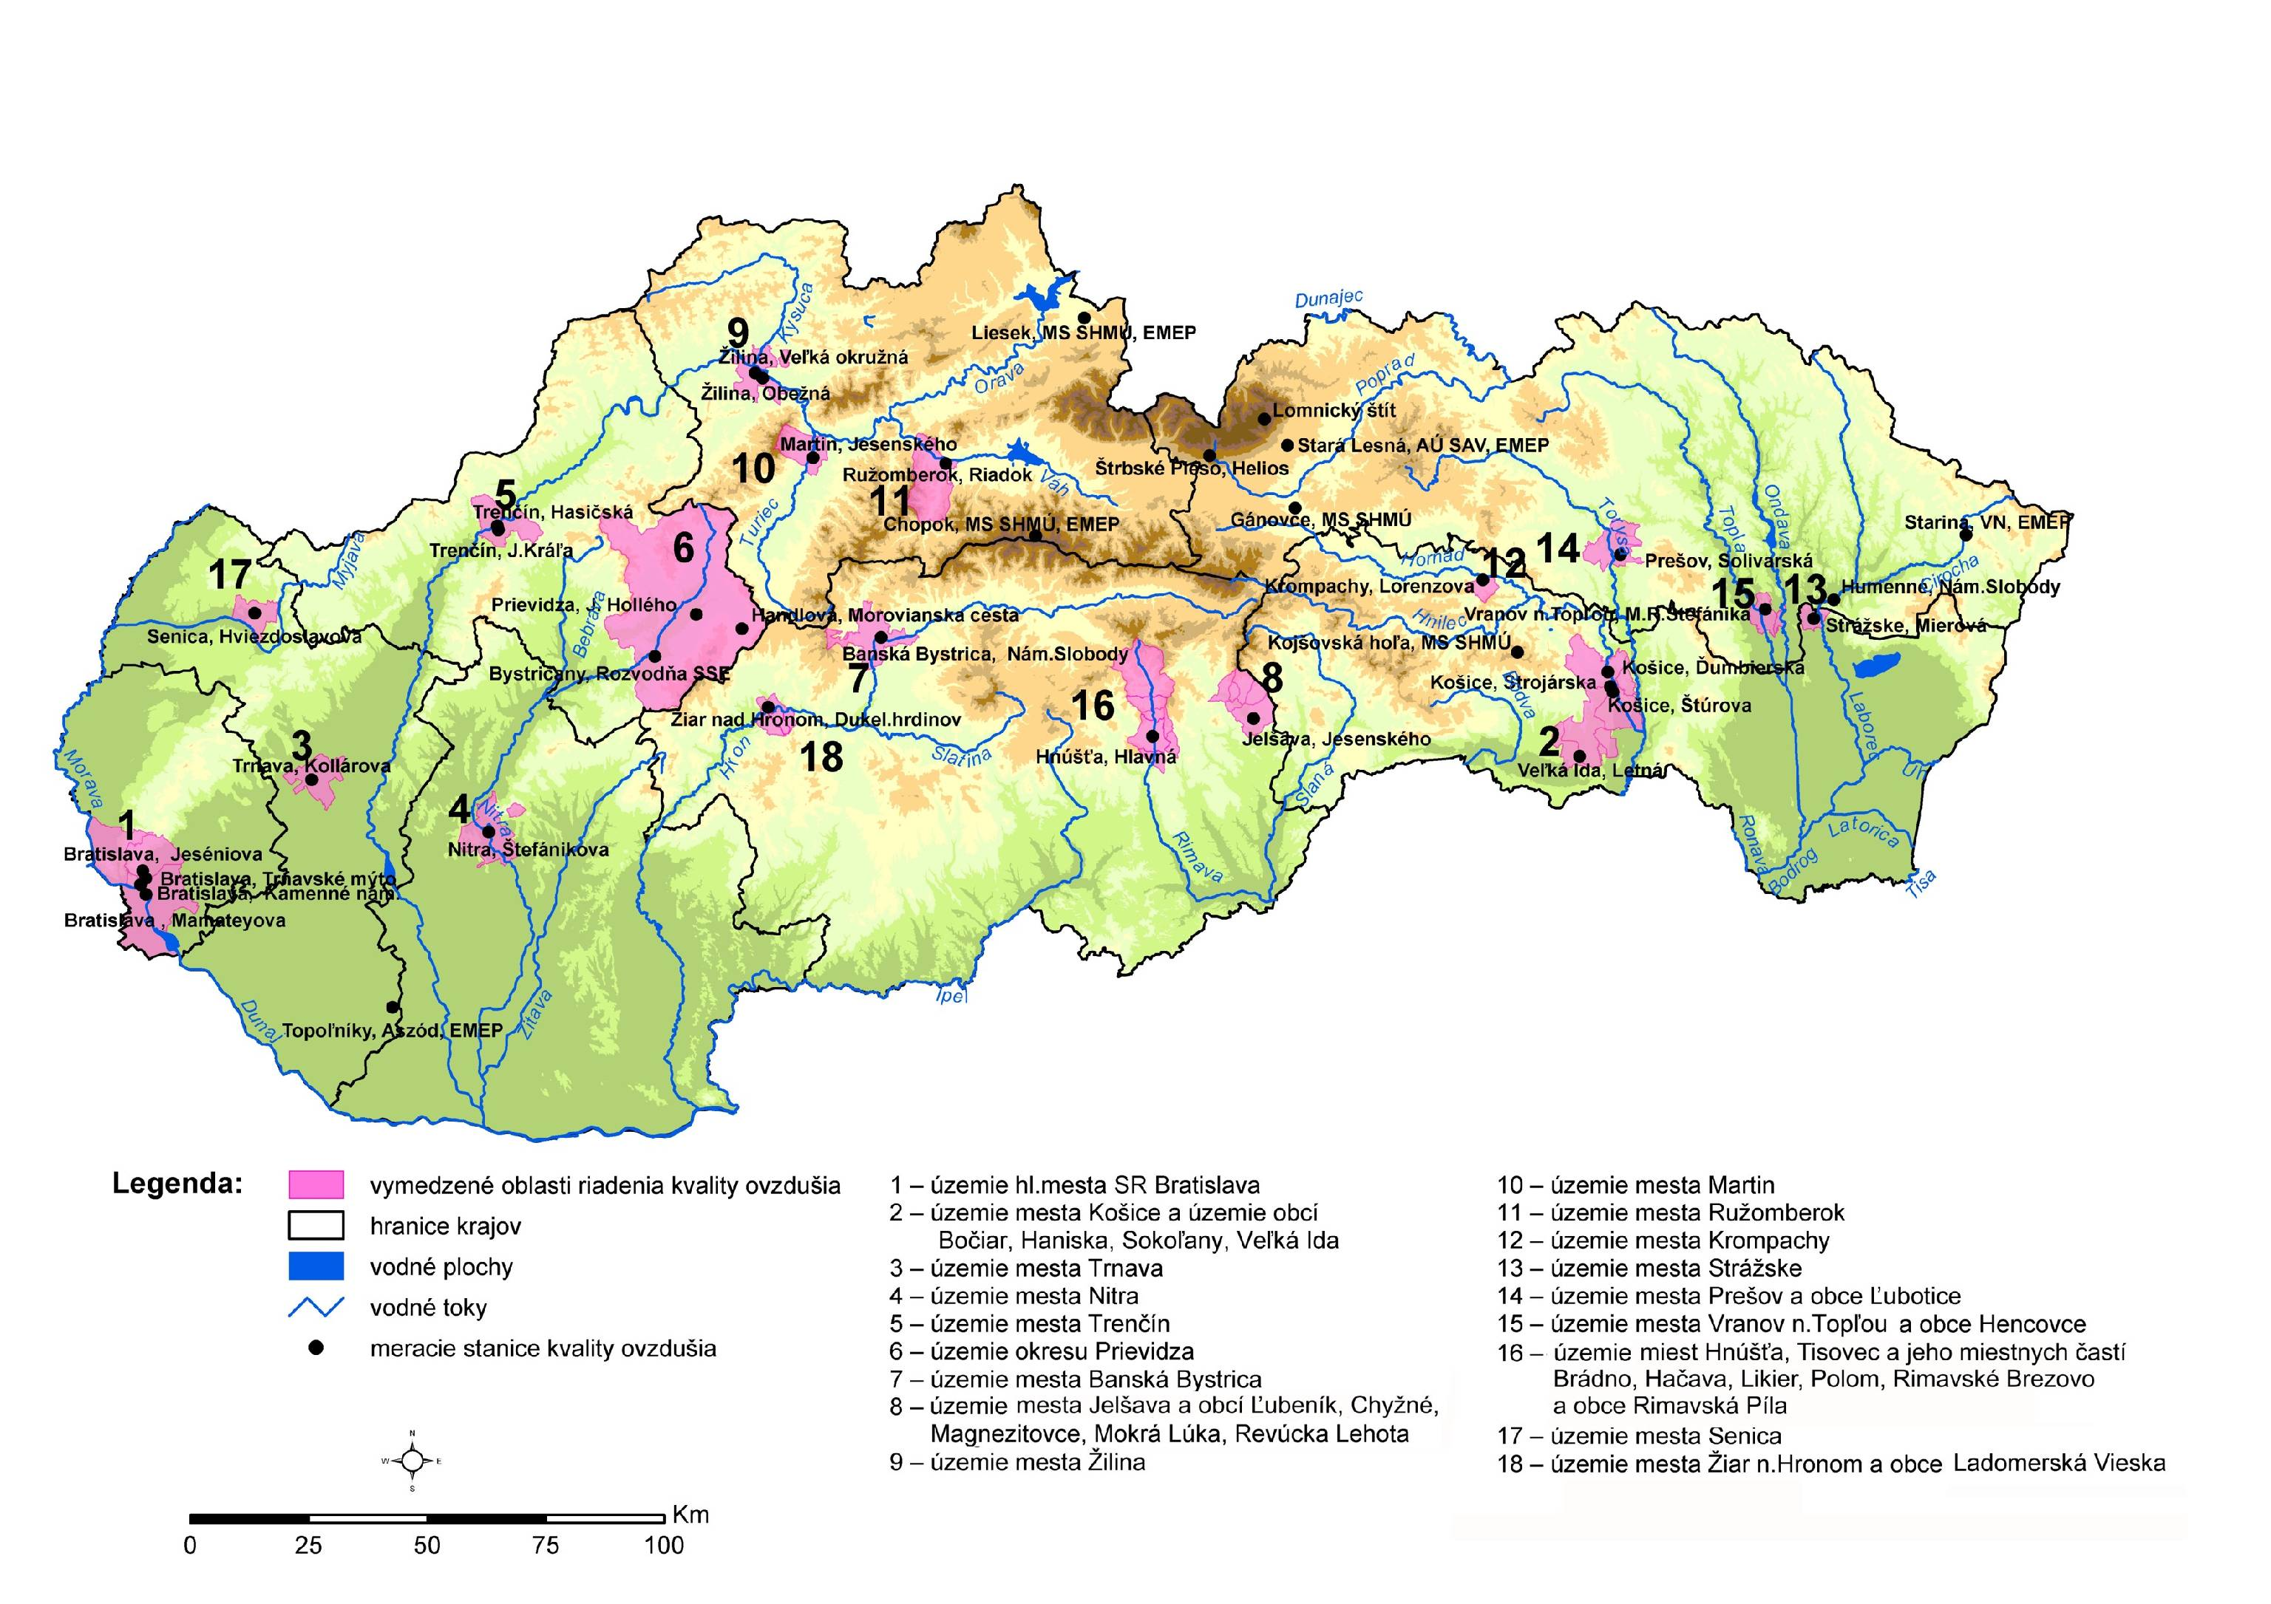

Areas of air quality management in Slovak Republic

Caption:

- defined areas of air quality management
- borders of regions
- water areas
- water course
- gauging station

- city area of Bratislava
- city area of Košice and Bočiar, Haniska, Sokoľany, Veľká Ida
- city area of Trnava
- city area of Nitra
- city area of Trenčín
- district area of Previdza
- city area of Banská Bystrica
- city area of Jelšava and Lubeník, Chyžná, Magnezitovce, Mokrá Lúka, Revúcka Lehota
- city area of Žilina
- city area of Martin
- city area of Ružomberok
- city area of Krompachy
- city area of Strážske
- city area of Prešov and Ľubotice
- city area of Vranov nad Topľou a Hencovce
- city area of Hnúšťa, Tisovec and Brádno, Hačava, Likier, Polom, Rimavské Brezovo, Rimavská Píla
- city area of Senica
- city area of Žiar nad Hronom and Ladomerská Vieska

