
User Note | JASPERS PROJECT : Financial - Economic Issues of Environmental Investment Projects - (2008 138 SK HOR HOR)
 | Methodology and Model for the Economic Evaluation of Water Supply and Wastewater Projects
 | October 2009

Methodology Approach

- Evaluation Period and Outputs

The model allows user discretion concerning the evaluation period and social discount rate applied. Outputs from the model comply with the requirements of Annex XXI – Major Project Request for Confirmation of Assistance Under Articles 39 to 41 of Regulation (EC) No 1083/2006. The main outputs are:

- Economic internal rate of return;
- Net present value expressed in Euro;
- Benefit Cost ratio;
- Composition of main costs and benefits.

The model is not designed to undertake subsequent sensitivity and risk analysis.

- Cost Parameters

The economic model considers both capital and operating costs arising from the implementation of the proposed project. It enables the user to input standard conversion factors for capital costs and operating costs to convert financial costs into economic costs. No recommendations are made within this analysis for the appropriate conversion factors that should be provided by the Managing Authority and consistently applied to all projects.

Allowances within the model and methodology exist for replacement of project assets during the evaluation period and the subsequent residual value of assets. For simplicity purposes, the proposed methodology treats the residual value as a negative cost and not as a benefit. The residual value is determined according to the remaining life of the asset with this valued by linearly depreciating the value of the asset over its assumed life. It is proposed that the assumed life of assets needs to be standardised (by the Managing Authority) and consistently applied. Minor variations in asset life can be tolerated to reflect particular project circumstances.

- Economic Benefits

Three main economic benefits are assumed namely user resource cost savings, environmental benefits and resource cost savings derived by the service provider. These are discussed in detail below.

Additional economic benefits from the implementation of water supply and wastewater improvement projects can arise, but are usually not quantified. These could include health benefits and multiplier impacts on the local economy as well as some less tangible environmental benefits. Within the proposed evaluation basis, it is suggested that

- Health benefits are not quantified owing to difficulties in establishing clear cause – effect relationships.
- In general, in the context of regional economies the individual projects are not expected to be significant and therefore any multiplier effects during implementation are expected to be small. It is therefore proposed that this potential benefit is also not quantified.
- Environmental benefits can also arise from reduction in methane emissions and other greenhouse gases. Reduction in methane in particular can arise from improvements in sludge management. Where sludge management improvements constitute a significant proportion of project costs, it may be appropriate to quantify this benefit. The benefit can be quantified by the calculation of the volume methane emissions in the with and without project scenarios. The economic value can be determined using an impact value for methane emissions (if a suitable value can be found) or can be derived on the basis of equivalent emissions of CO₂ for which the emission trading price can be applied as a proxy for its economic benefit.

However, these three benefits can be described in qualitative terms as required in Section E.2.5 of the abovementioned Annex XXI.

The economic benefits that can be quantified are:

- Resource cost savings to the User (Household)

This economic benefit quantifies the benefits realised to the household where a new connection to the water supply and / or sewage system are made. The economic methodology is based on the resource costs saving approach, where the economic benefit is established as the costs that would be incurred by the household in the without project scenario. Sub components of this benefit also quantify the benefits to the household for improvements in the quality of water supply. Since, there are few examples in Slovakia of water shortages, the methodology does not include an economic benefit for improvements in service standards or the availability / quantity of water supplied.

These are for water supply:

  - For new connections provided by the project – the reduction in the cost to the household of having to obtain water for a garden well and any other costs included for the household treatment of such water (ie filtration or boiling) and the cost of purchasing bottled water to meeting drinking and or cooking purposes.

Establishing the economic cost of own wells should include annual maintenance costs, electricity for pumping (where appropriate) or time taken to abstract water, and an annual allowance for replacement. The latter can be determined from the economic cost of constructing the well divided by its economic life. It is suggested that a common value for this parameter is determined with flexibility being allowed to take account of local conditions (depth and quality of local groundwater).

  - For improvements to water quality by the project – reduction in the cost incurred by all affected consumers for the purchasing of bottled water to meet drinking and or cooking purposes.

Where new connections to the sewer system are made within the project, these are for wastewater:

  - Savings in the maintenance of septic tanks. The analysis assumes in the existing situation that households without a connection to a sewer system dispose of wastewater to a closed septic tank.

The economic cost of a septic tank should be established in a similar manner to the above proposed approach for valuing individual wells. This cost should be applied consistently across projects.

  - Savings in the emptying of a septic tank – this relates to the costs incurred by the household for the regular emptying of the septic tank.

The financial charge levied by the water company (or private sector supplier) for emptying a septic tank can be used as a proxy for the economic benefit (willingness to pay). The analysis should confirm that the financial charge at least recovers all costs incurred, and where not appropriate changes should be made. In circumstances where a large profit element is found, this can be retained providing that the existing service is reasonably well used. The financial charge should be applied to a theoretical calculation of the number of times per annum a septic tank should be emptied. This latter value should be centrally determined and consistently

- Environmental Benefits Related to Improved Wastewater Treatment (or coverage) and Impact on Water Courses

The environmental benefits are mainly used to quantify the impact of improving the standard of wastewater treatment. The benefits can be extended to include increased sewage connections on the understanding that mainly of existing septic tanks (or other employed means of disposing of household wastewater) in practice result in a less effective standard of treatment. Where, the latter option is applied it is recommended that lower impact values are applied.

Benefits from improvements to affected water courses can be valued according to the willingness of the population to pay for the improvement. Valuation of the benefit can be achieved through detailed studies (contingent valuation surveys) as part of the project preparation process or proxy values can be taken from similar and relevant other studies in Slovakia. However, the former is time and cost intensive and generally not undertaken as part of the project preparation process in Slovakia. Extensive other studies in Slovakia that could be used to establish proxy values are not known.

In the absence of these studies, it is proposed to establish an economic value to make reference to the findings of the EC report on the ‘Benefits of Compliance with the Environmental Acquis for Candidate Countries’, produced by Ecotec et al in 2001 (the Acquis report). This report evaluated the benefits of full compliance to EU environmental standards for all Accession countries. These benefits were assessed using specifically conducted studies in the Accession countries as well as by reference to studies in Western European and other countries.

The evaluation applies countrywide benefits to the proposed project and takes account of existing compliance of infrastructure in the water and wastewater sector in the country together with local environmental conditions and their use. On a project basis, these benefits would accrue not to the total population of the country but rather to the population of the project area.

The Acquis report evaluated the following benefits in the water / wastewater sector:

- Health - Availability of drinking water and improvements in quality;
- Resource benefits – Recreational and downstream uses;
- Eco-systems – River water quality

Four types of benefits from water / wastewater related legislation were identified in this report:

- The provision of cleaner drinking water;
- Improved bathing and other surface water quality - representing a use value;
- Improved river eco-system quality - representing a non-use value;
- Angling related benefits.

The second and third of the above benefits are used in the economic evaluation of projects. The provision of cleaner drinking water is separately discussed (see above). Angling related benefits are not separately evaluated, as this would involve a double counting of benefits with those valued for improved bathing and other surface water quality use values.

The Acquis report gives the following values for benefits (in Euro in 1999 prices):

- For valuation of improved bathing and other surface water quality (user value)

Economic values for improved bathing (user values) are established on an annual per capita basis. The determined economic values from the Acquis report are given in the below table (1). It is proposed that the low value should be used, as most projects only include the introduction of tertiary treatment. The values have been established in the year 1999 prices and need to be escalated. A common escalation factor needs to be determined. Since, the values represent individual’s willingness to pay, the escalation factor should be derived from changes in household income levels (and should remove inflationary and exchange rate effects).

Table 1 User Values (Euro per annum per person – 1999 prices)

Country | Low | High
Slovakia | 20.71 | 25.45
Slovenia | 31.47 | 38.67
Czech Republic | 26.30 | 32.31
Hungary | 22.50 | 27.64

Determining the economic benefit, requires establishing the number of people in the project area and the number (percentage) of these use the affected water course(s) where a tangible improvement from project implementation can be found. These factors need to be determined on a project by project basis and should take account of the importance of the affected water course(s). The following could be used as a basis:

Impact of the Project on achieving the compliance with EC Directives | Factor by which the Project influences the compliance with EC Directives
High | 0.67 – 1.00
Medium | 0.34 – 0.66
Low | 0.00 – 0.33

- Non User Value for an improvement from fair condition to good condition.

As above, since water quality in water courses is generally in a reasonable condition and projects mainly comprise modest improvements to the quality of effluent discharges, it is proposed that the lower value measures (improvements from fair to good conditions) is applied. The value determined by the Acquis report is given in the below table, and again requires escalating from year 1999 prices to the base year price. The same escalation factor as applied for user values (see above) should be used.

Table 2 Non User Value for improvement of water courses from Fair to Good (Euro per household per km of water course – 1999 prices)

Country | € per person per km
Slovakia | 0.0013
Slovenia | 0.0010
Czech Republic | 0.0017
Hungary | 0.0014

Quantification of the benefit requires an estimate to be made of the length of improved water course (in km) and the proportion of the national population that would have a non use value. The latter should take into account the importance of the affected water course and the degree to which it is known by the wider population. The following could be used as a basis:

Impact of the Project on achieving the compliance with EC Directives | Factor by which the Project influences the compliance with EC Directives
High | 0.67 – 1.00
Medium | 0.34 – 0.66
Low | 0.00 – 0.33

- Resource cost savings to the Operator (Water / Wastewater Company)

Since cost eligibility criteria in Slovakia largely exclude rehabilitation / replacement works it is considered that opportunities for the resource cost savings benefits to the service provider will be limited. Nevertheless, a comprehensive array of benefits is considered.

The economic methodology is again based around the resource costs saving approach, where the economic benefit is established as the costs that would be incurred by the water supply / wastewater company in the without project scenario. The main quantified benefits are summarised below.

- Reduction in unaccounted for water / infiltration – these are valued at the incremental costs of water treatment / pumping and pumping / wastewater treatment against the projected changes in volumes in the with and without project scenarios. The incremental costs should be determined on the basis of the existing cost of service provision;
- Savings in operating cost from system improvements – these benefits could primarily relate to benefits of replacement of infrastructure and take account of efficiency gains (reduced maintenance / lower energy consumption) that can be realised from the employment of more modern technologies and infrastructure. Valuing benefits can be established from existing operating costs. However, for savings in maintenance it is often more reliable to use intended maintenance needs rather than actual expenditure that in practice can be reduced owing prevailing financial constraints.

Use of the Economic Evaluation Model

- Structure of the Model

The economic model is presented as a MS EXCEL Spreadsheet. It comprises:

- 9 input worksheets;
- 1 calculation worksheet;
- 2 output worksheets.

The model requires the user to enter input data (highlighted in green). Calculations are automatically provided within the model and necessary numerical outputs for the completion of the Application Form are provided.

- Input Requirements

The following input worksheets are provided:

Economic Input Data | The data for this input table should be common to all projects and should be provided by the Managing Authority. Individual projects should be able to independently enter the start year of the evaluation.
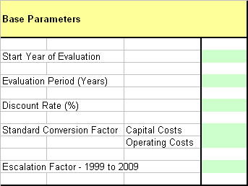

Capital Cost Input Data | Data should be entered in million Euro. The costs should be entered in constant prices and should exclude contingencies and other allowances. A construction period of up to 5 years is included. For the purpose of determining replacement needs and the residual cost have been distinguished between types of infrastructure and between civil works and mechanical and electrical works. Where this information is not available, a single entry can be made providing that this is taken into account in determining the asset life.
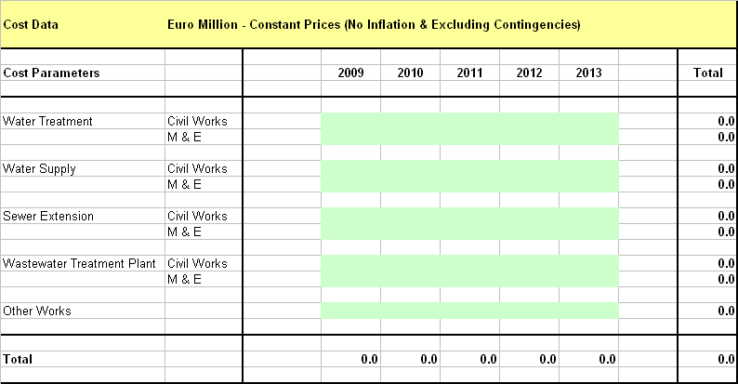

Asset Life Input Data | Data entry requires expected life of assets. Benchmark parameters should be centrally provided. The use should ensure where investments take place asset life parameters are entered.
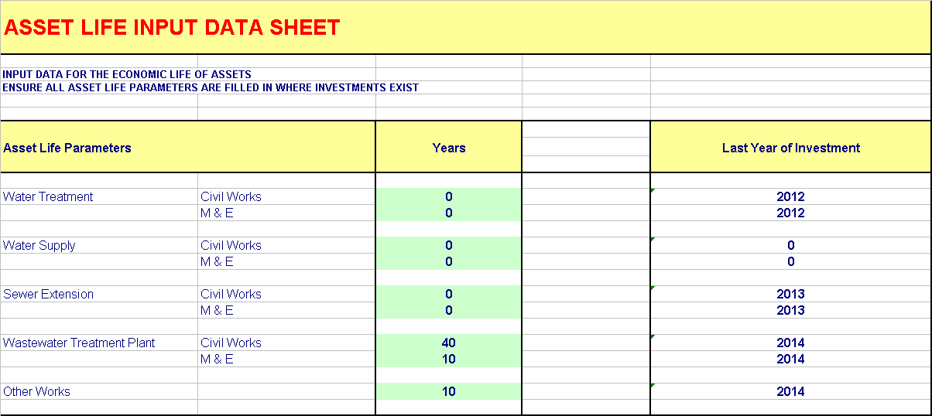

Operating Cost Input Data | This input sheet is used to calculate the specific operating costs of project infrastructure. The costs should be entered in base year prices (without inflation). These will need to be established using best engineering practices and should be the same as those used in the financial analysis. The model assumes unit costs applied in the last year of data entry will continue throughout the remainder of the evaluation period.
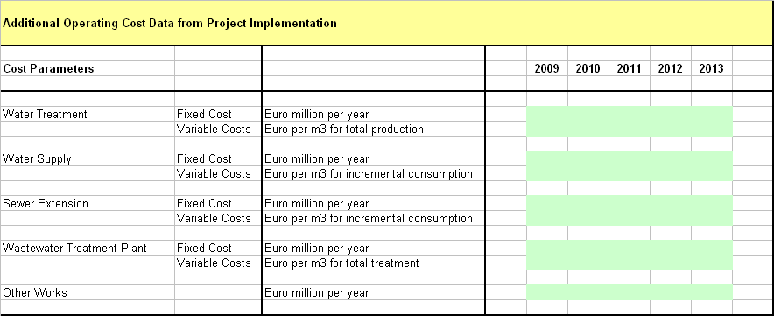

Connection Input Data | The user is required to input the existing number of population connected to the water supply and wastewater systems and the number to be connected as part of the project. An average size of household (number of people per house) is also required to be entered, with this used to convert population connected to number of connections.
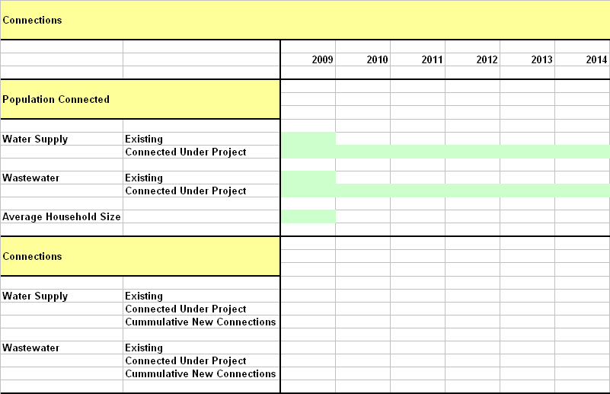

Consumption Input Data | Water supply and wastewater discharge assumptions need to be entered on an annual basis over the evaluation period. Data should be entered as m³ per annum for the with and without project scenarios. The data should be available form the demand analysis and the projects’ financial analysis.  The data is required for the calculation of incremental operating costs, and resource cost savings derived by the user and the service provider.
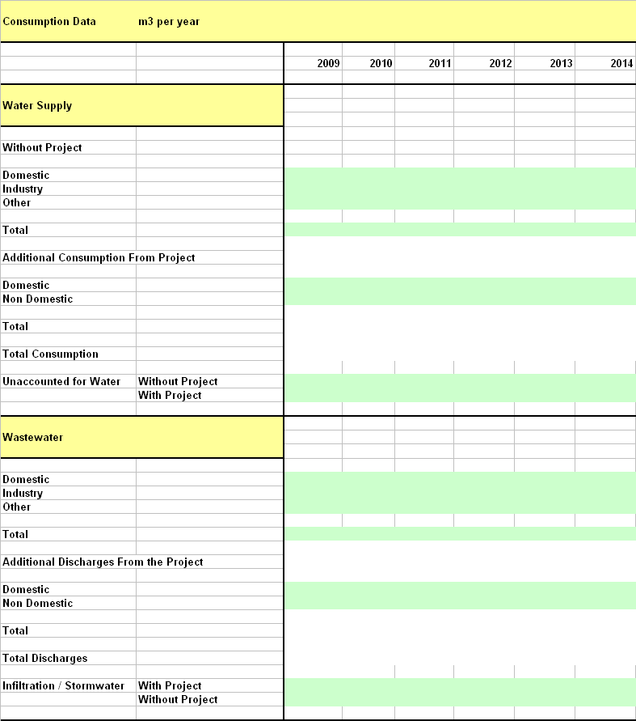

Consumer Savings Input Data | Standard values need to entered for maintenance cost of a septic tanks and a well. Importantly, this cost should include an allowance for replacement. These costs should be applied for a properly maintained and used own system and not as practised.  Other data should be derived from existing charges and assumptions regarding use patterns.
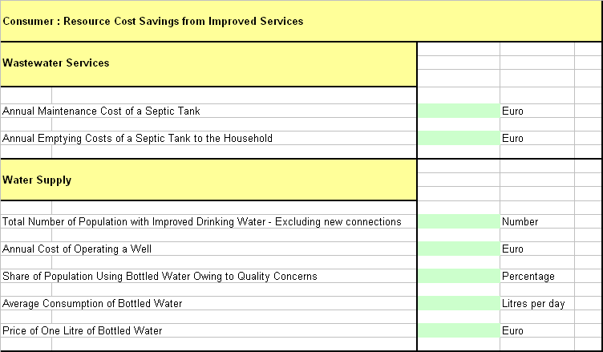

Environmental Benefits | Input parameters are the population within the project area and assumptions regarding the proportion of these that can be considered as users / non users. It is recommended that conservative values for user / non user parameters are applied. In establishing these, the size and condition and project impact on the affected water courses should be taken into account.
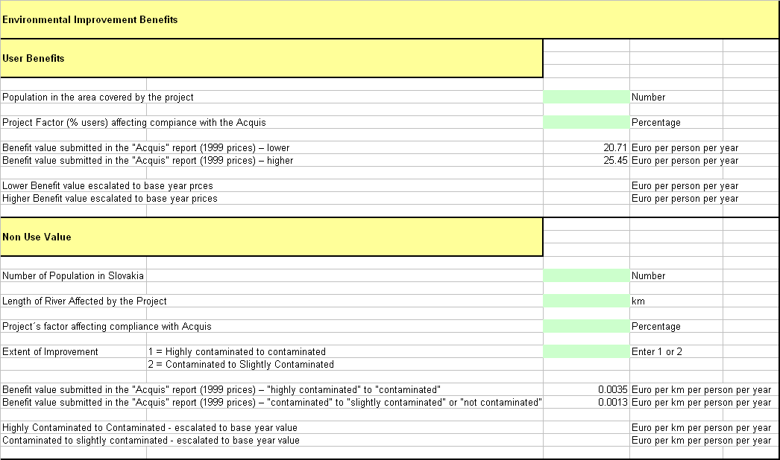

Operator Cost Savings Data | These are used to determine economic benefits derived by the service provider. The existing service costs should be determined from the existing operating position. Savings from replacement should be calculated using best engineering practices.
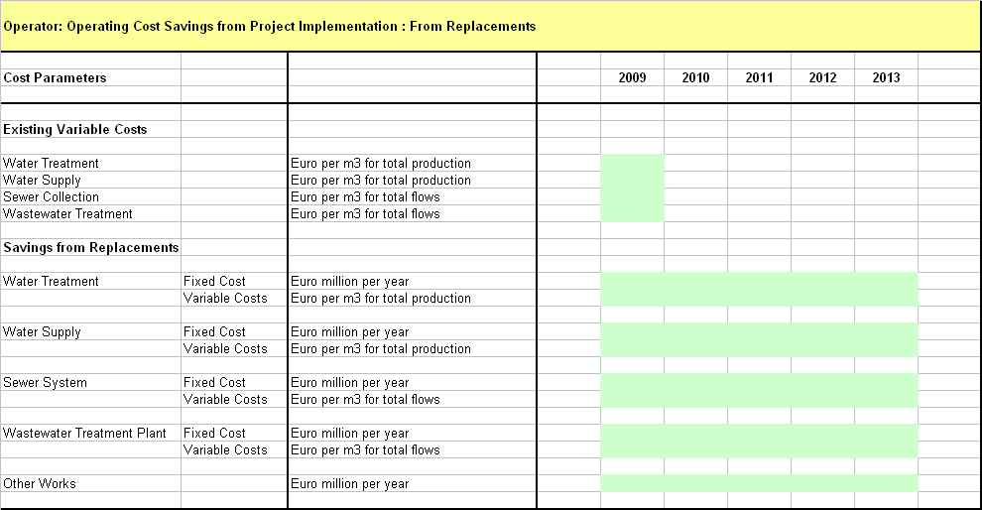

- Output Statements

Output statements are presented to provide the information required to complete section E.2.2 and E.2.3. Output statement for E.2.2 contains an analysis of the composition of economic benefits and costs. Output statement for E.2.3 includes the economic internal rate of return, economic net present value (in Euro) and the benefit cost ratio. These are automatically calculated within the economic model.

- Calculation Basis

The main calculations used in the economic model are given below. The formulae in the model also include IF statements that are mainly related to ensuring model integrity when the project start date and evaluation periods are changed.

- Capital costs

=+'Capital Cost Input Data'!E31*'Economic Input Data'!$H$19

- Operating Costs – Water Incremental Costs

= +((+'Operating Cost Input Data'!F$17+'Operating Cost Input Data'!F$18*('Consumption Input Sheet'!D$29+'Consumption Input Sheet'!D$32)/1000000))*'Economic Input Data'!$H$20+((+'Operating Cost Input Data'!F$20+'Operating Cost Input Data'!F$21*('Consumption Input Sheet'!D$27)/1000000))*'Economic Input Data'!$H$20)

Variable operating costs for water treatment are multiplied by water production (consumption plus unaccounted for water). Variable operating costs for distribution are multiplied by incremental consumption.

- Operating costs – Wastewater Incremental Costs

= +('Operating Cost Input Data'!F15+'Operating Cost Input Data'!F16*'Consumption Input Sheet'!D47/1000000)+('Operating Cost Input Data'!F18+'Operating Cost Input Data'!F19*('Consumption Input Sheet'!D47+'Consumption Input Sheet'!D51)/1000000)

Variable operating costs for wastewater treatment are multiplied by total flow at the plant (discharges plus infiltration). Variable operating costs for collection and conveyance are multiplied by incremental consumption.

- Resource cost savings – new water connection

= + 'Connection Input Sheet'!D$26*'Consumer - Savings Input Data'!$D$19/1000000+'Connection Input Sheet'!D$26*'Connection Input Sheet'!D$18*'Consumer - Savings Input Data'!$D$23*'Consumer - Savings Input Data'!$D$25/1000000

First part is the calculation of annual savings from operating a well, the second part is savings from reduced purchase of bottled water for which it is assumed that all households with wells will do.

- Resource cost savings – new wastewater connection

= +'Connection Input Sheet'!D$26*'Consumer - Savings Input Data'!$D$19/1000000+'Connection Input Sheet'!D$26*'Connection Input Sheet'!D$18*'Consumer - Savings Input Data'!$D$23*'Consumer - Savings Input Data'!$D$25/100000

- Resource cost savings – improved water quality

= +'Consumer - Savings Input Data'!$D$17*'Consumer - Savings Input Data'!$D$21*'Consumer - Savings Input Data'!$D$23*'Consumer - Savings Input Data'!$D$25/1000000

- Environmental Benefits – User Value

= + 'Environmental Benefits '!$D$9*'Environmental Benefits '!$D$11*'Environmental Benefits '!$D$16/1000000

- Environmental Benefits – Non Use Value

= +'Environmental Benefits '!$D$23*'Environmental Benefits '!$D$25*'Environmental Benefits '!$D$27*'Environmental Benefits '!$D$35/1000000

- Service Provider - Resource cost savings reduced unaccounted for water

= +('Consumption Input Sheet'!D30-'Consumption Input Sheet'!D29)*('Operator Cost Savings Data'!$F$11+'Operator Cost Savings Data'!$F$12)/1000000

Calculated on the reduction in unaccounted for water between the with and without project scenarios.

- Service Provider - Resource cost savings reduced infiltration

= +('Consumption Input Sheet'!D$51-'Consumption Input Sheet'!D$52)*('Operator Cost Savings Data'!$F$13+'Operator Cost Savings Data'!$F$14)/1000000

Calculated on the reduction in infiltration / stormwater flows between the with and without project scenarios.

